Info about Campus Party for CARPE partners
About Campus Party
From the Campus Party website:
Campus Party is the greatest technological experience of the world which brings together young geeks & aspiring entrepreneurs in a festival of innovation, creativity, science, digital entertainment & entrepreneurship.
Campus Party will return to Europe, where it’s fourth edition will be held in Utrecht, The Netherlands on 25 – 29 May 2016. This weeklong, 24-hours-a-day technology event is the place to be for young technical talent to innovate, learn and engage with some of the biggest names in technology. Thousands of “campuseros” including geeks, nerds, designers, developers, gamers, hackers, scientists, startups and other fans of Internet and technology will all come together during intense days of networking and activities such as workshops, hackathons and competitions about innovation, creativity, science and digital entertainment and entrepreneurship.
Campus Party is one of the events under the flag of Startup Fest Europe, which is a week long Festival that takes place during the European presidency by The Netherlands. Each day events will take place that focus on startups, in different Dutch cities. Campus Party hosts the closing event of Startup Fest.
Campus Party & CARPE
HU University of Applied Sciences Utrecht is closely involved in the preparations for the Campus Party and will be represented at Campus Party by a group of (a minimum of) 525 students. Furthermore HU will deliver keynote speakers, workshops and challenges, through the following package deal:
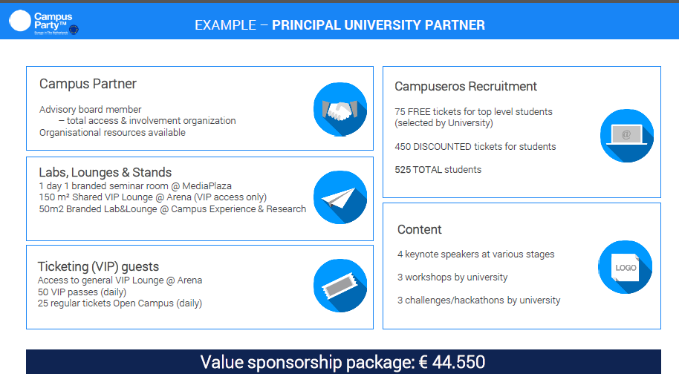
In addition to the tickets for HU students in the package deal, HU has negotiated a number of free tickets for students from all CARPE partners (regular fee is €165 per student. Each CARPE partner is invited to nominate max. 50 students to take part in the Campus Party. A ticket covers: participation and overnight stay at Campus Party. Travel costs (and probably costs for food – to be confirmed) need to be covered by the students themselves and/or their home university.
The following picture shows the participant’s categories. The students we aim at will fall in the categories Talents and Innovators & Geeks. [Other categories might be of interest to CARPE partners as well; consult the Campus Party website for more info on the other activities and/or consult HU (hans.hoving@hu.nl) to discuss possibilities for (joint) participation in these other categories.]
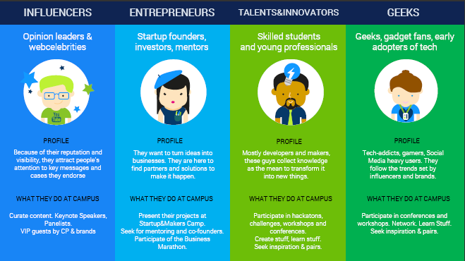
Request to CARPE partners
CARPE partners are kindly requested to:
- indicate if and with how many students they would like to take part in Campus Party;
- to nominate a general contact person for the participation in Campus Party on behalf of their university;
- submit any questions or ideas about the CARPE participation.
HU would like to receive the response from all CARPE partners latest February 15, 2016, since the number of participants need to be confirmed to Campus Party in February.
Please send your responses to Marlies Ngouateu, CARPE co-ordinator at HU (marlies.ngouateu-bussemaker@hu.nl) and Hans Hoving (hans.hoving@hu.nl), intermediairy between HU/CARPE and Campus Party.

