NO COVER PAGE

Resumen
La memoria del TFG/TFM empieza con un breve resumen de entre 150 y 200 palabras, escrito en castellano, valenciano e inglés. Estas páginas van sin numerar.

Resum
La memoria del TFG/TFM comença amb un breu resum d’entre 150 i 200 paraules, escrit en castellà, valencià i anglès. Aquestes pàgines van sense numerar.

Abstract
The thesis begins with a short abstract (between 150 and 200 words) written in Spanish, Valencian, and English. The cover page and the pages containing the three versions of the abstract are not numbered.

EXECUTIVE SUMMARY
The degree thesis must develop in the text the following concepts, appropriately justified and discussed, focusing on the FIELD OF STUDY
CONCEPT (ABET) | Done?  (Y/N) | Where?  (page numbers)
- IDENTIFY:
  - Problem statement and opportunity
  - Constraints (standards, codes, needs, requirements & specifications)
  - Setting of goals
- FORMULATE:
  - Creative solution generation (analysis)
  - Evaluation of multiple solutions and decision-making (synthesis)
- SOLVE:
  - Fulfilment of goals
  - Overall impact and significance (contributions and practical recommendations)

Table of contents

Chapter 1. Purpose of this document 2
Chapter 2. Thesis Format 3
2.1 Language 3
2.2 Fonts 3
2.3 Structure 3
2.3.1 Paragraphs 3
2.3.2 Chapters, Sections, sub-sections 3
2.4 Figures, tables and equations 3
2.5 References 4
Chapter 3. Sections 5

Purpose of this document
This document aims to provide general guidelines and a style guide for the preparation of the Bachelor’s thesis / Master’s thesis .

Thesis Format

Language
The thesis may be written in Spanish, Valencian, or English.

Fonts
Times New Roman, or a similar font type, will be used. Font size must be at least 11 points for the main text and at least 9 points for captions and footnotes.

Structure

Paragraphs
Paragraphs must be justified, and paragraph spacing must be at least 6 points.

Chapters, sections, sub-sections
The chapters shall be numbered, and the text shall be structured appropriately in numbered sections and subsections.

Figures, tables and equations
Figures and tables must be numbered and include a descriptive caption. The sequence of figure numbers will be independent of that of the table numbers. Displayed equations (i.e., those which are not within text) must also be numbered. Figures and tables must be properly mentioned in the text and figures/tables should not appear before the first text citation to them. Moreover, the first text mentions to figures and tables must be in numerical order (e.g., Fig. 2 cannot be mentioned before Fig. 1).
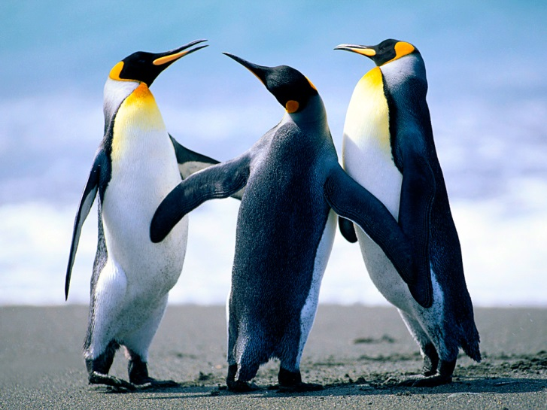
Figure 1. Example of a figure.
Column 1 | Column 2 | Column 3 | Column 4
Table 1. Example of a table.
The following is an example of an equation:

${\left(1+x\right)}^{n}=1+\frac{nx}{1!}+\frac{n\left(n-1\right)x^{2}}{2!}+…$ (2.1)

References
The thesis must include an unnumbered section with a detailed list of the sources that are appropriately cited in the text of the report. Follow the notation and conventions shown in the following examples:
[1] Wilkins, R.; Little, J. “Solution of electrostatic field problems using Sander's function,” IEEE Transactions on Microwave Theory and Techniques, vol. 55, no. 9, pp. 1880–1886, September 2007.
[2] Ansoft Corporation, “HFSS: 3D high-frequency electromagnetic simulation,” http://www.ansoft.com/products/hf/hfss/index.cfm. [Online].
[3] Matthaei, G.; Young, L. and Jones, E. M. T. Microwave Filters, Impedance-Matching Networks, and Coupling Structures. Artech House Inc., 1980.

Sections
Pages must be numbered with numbering starting at the page where Chapter 1 starts. It is recommended that the report does not exceed 75 pages, including appendices.
It is recommended that the report includes the following:
- Cover page
- Abstract
- Table of contents
- Introduction
- Objectives
- Methodology
- Development and results
- Specifications, budget, plans, technical diagrams, materials, equipment, etc. (if applicable)
- Conclusions and proposals for future work
- References
- Appendices (if applicable)

